Document:

Table script added in Application inside DB_Document Folder

Steps to Run:-

1.Add Employee :- All fields are mandatory, Email Validation added

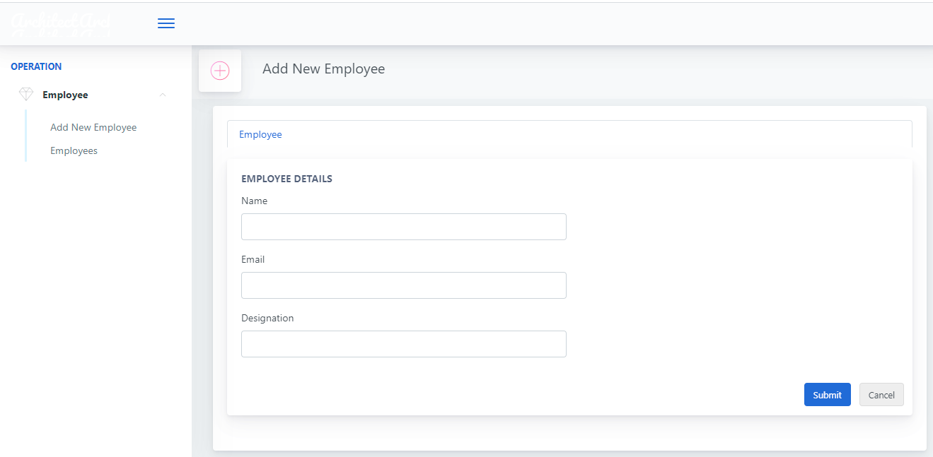

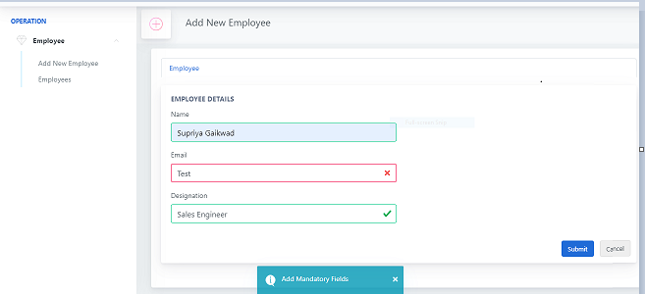

2. Employee List :- Employee can edit or delete

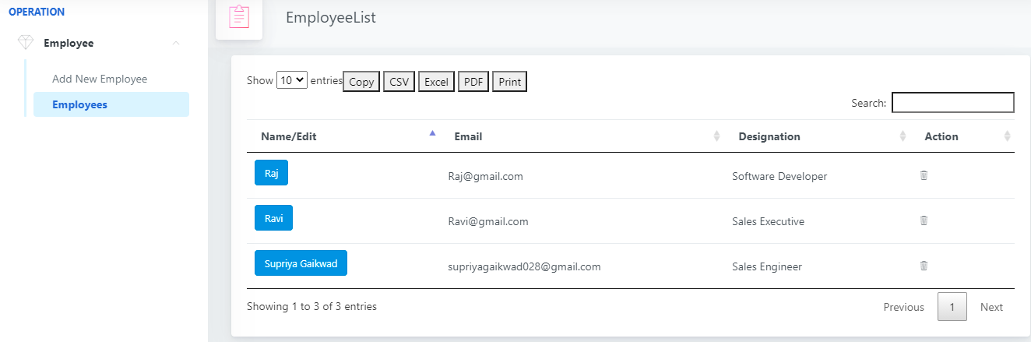

3. Add Document :- While modifying employee having option to add documents in Details tab.

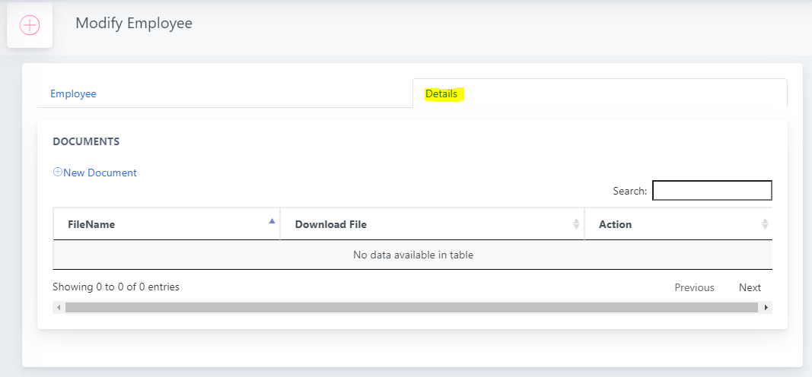

4. Add new Documnet

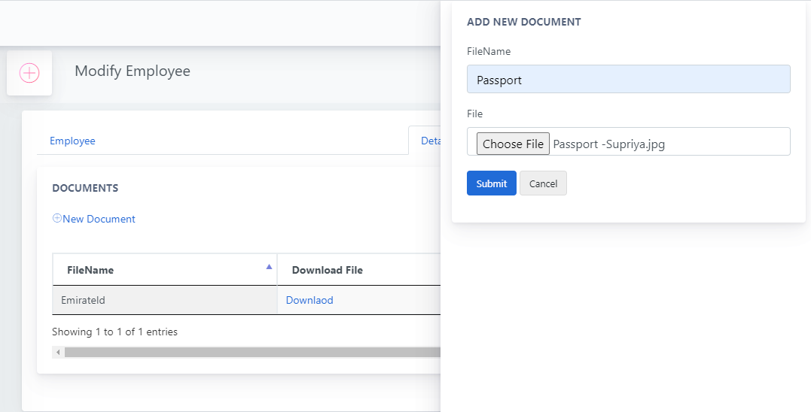

5.Document List :- Download document or delete document.

